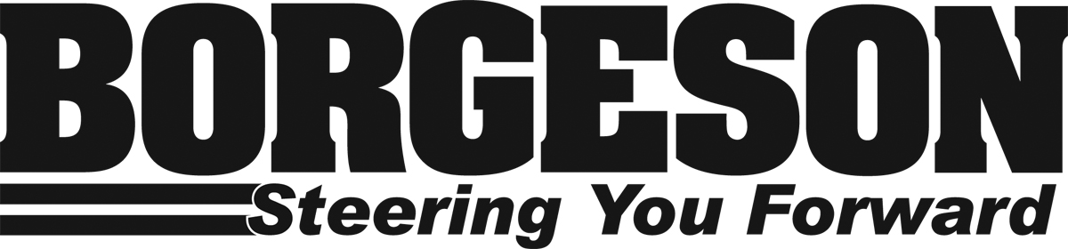
800132 Chevy C10 12.7:1 Power Steering Up-Grade

PARTS AVAILABLE FOR THIS APPLICATION:

Part # | Description
990012 | Half Rag Joint ¾”-30 spline, required for pre-1977 vehicles.

REMOVAL:

- Disconnect existing power steering hoses and drain fluid into a catch pan.

- With a pitman arm puller remove pitman arm from gearbox. A whack or two on the side of the arm while under tension from the puller will help loosen up stuck arms.

- Split the existing rag joint at the column by unbolting the flange.

- Remove the three or four bolts securing the box and remove the steering box from the car.

NOTE: Trucks with original factory manual steering will require a power steering pitman arm.

INSTALLATION:

- Install the new half rag joint connector #990012 on the new gear box. Be sure the shaft is fully engaged into the rag joint and tighten the set screw then lock nut.

- Using the installed rag joint, center the steering box by turning the box full to one side then counting the revolutions as you turn the rag joint completely to the other side. Now bring the box back to center by only rotating it half of the total turns. Total box turns will be +/- 3 with 1.5 turns from full lock to center. At the center position the four master splines on the pitman shaft will be at 3,6,9 and 12 O’clock positions

- With the bolts removed earlier, bolt the steering box to the frame.

- Bolt the steering column rag joint flange to the new rag joint with the hardware provided.

- Install the pitman arm on the gearbox and fasten with new nut and lock washer provided.

- This steering box is designed to use O-Ring fittings. We have included these 2 Brass inserts to convert the steering box to inverted flare fittings. For use with inverted flare hoses insert the two provided brass ferrules in to the steering box pressure and return fittings you may be required to tap the inserts in place with a small punch. If you are presently using O-Ring hoses please discard these inserts.

- Connect the gearbox to the power steering pump with either hose kit #925103 or your original power steering hoses. The pressure line is the larger 11/16(18mm) hose port located closest to the engine.

- Fill the power steering system with a quality P/S fluid. With the engine running check new system for leaks and bleed off any air trapped in the system by slowly turning the wheel full left to full right with the wheels off the ground. Be sure to keep reservoir full.

Borgeson Universal Co., Inc.
9 Krieger Dr. Travelers Rest, SC 29690
www.borgeson.com
5/14/19

